CSA-0805-PYTHON PROGRAM
LEVEL- 1
NAME:D.Poornachandra DATE:-15/10/25
REG NO:-192424267 SUBJECT:-Python
- Read the number until -1 is encounter. find the avg of positive numbers and
negative numbers entered by user
Sample Input:
Enter -1 to exit, enter the numbers 7,-2,9,-8,-6,-4,10,-1
Output: avg negative number is -5, avg positive number is 8
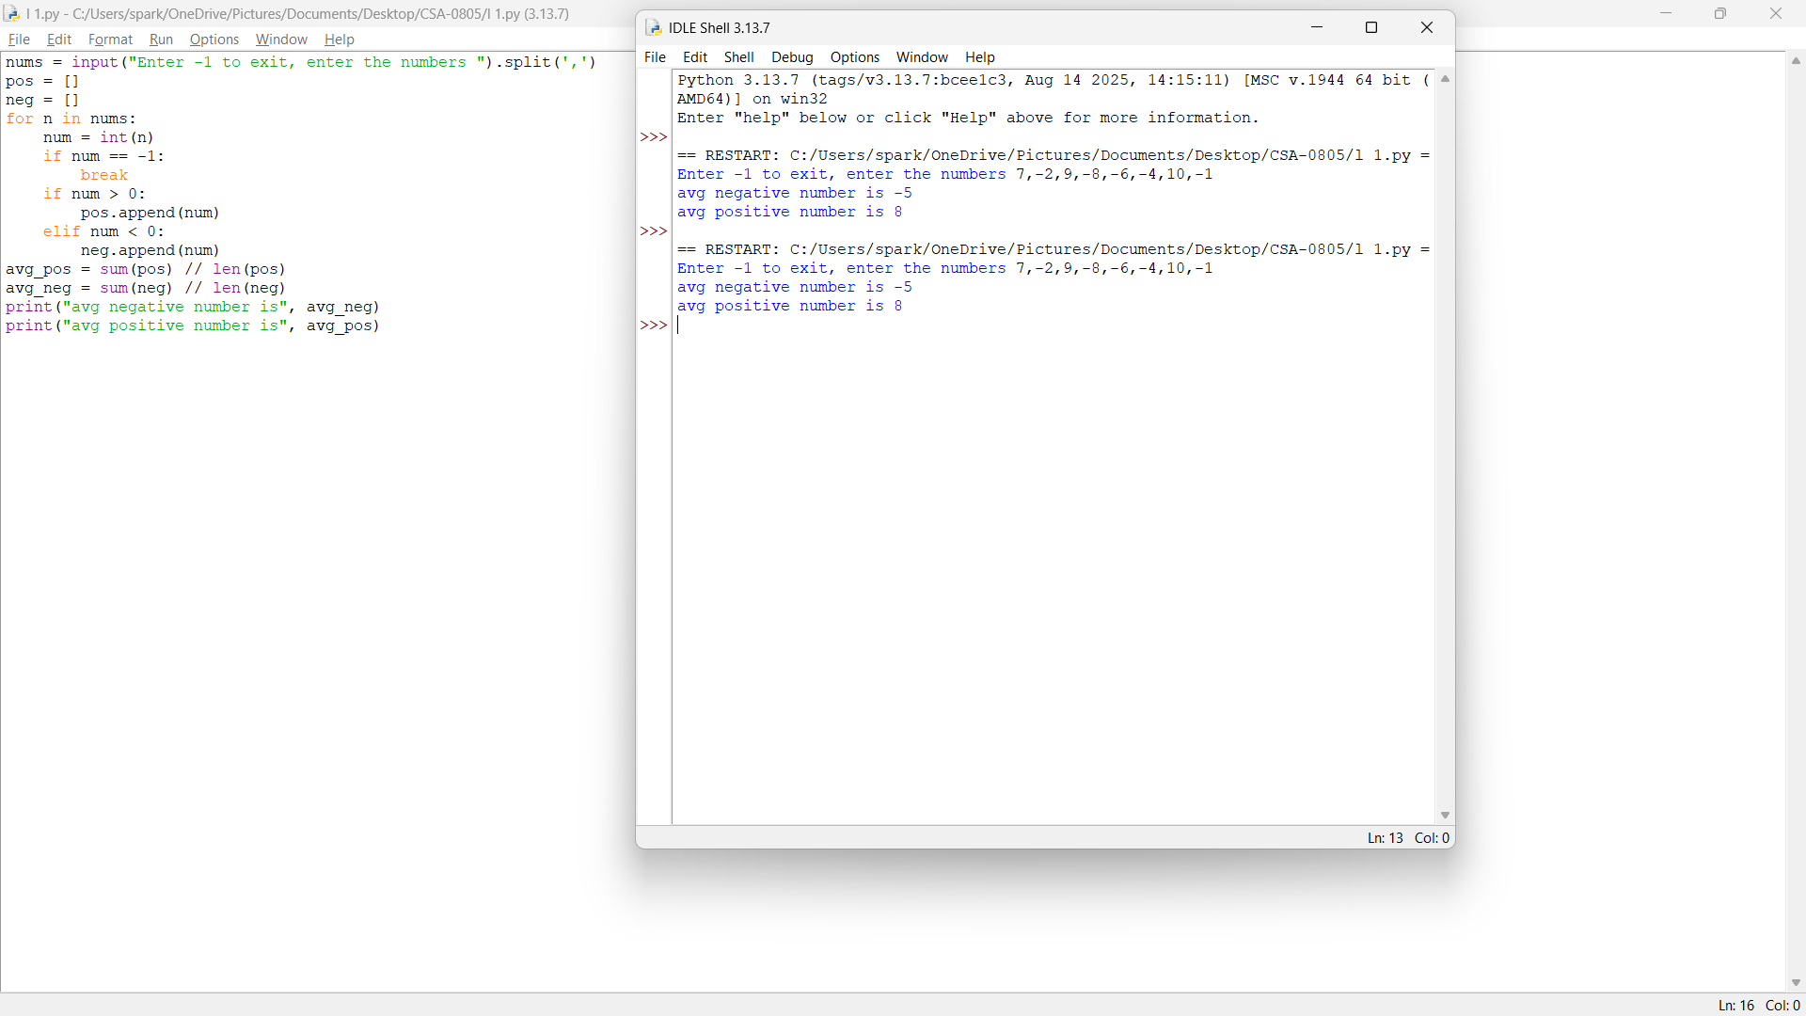

2.Write a python program to find the square, cube of the given decimal number. Sample Input:
Given Number: 0.6
Output:
Square Number: 0.36
Cube Number:0.216

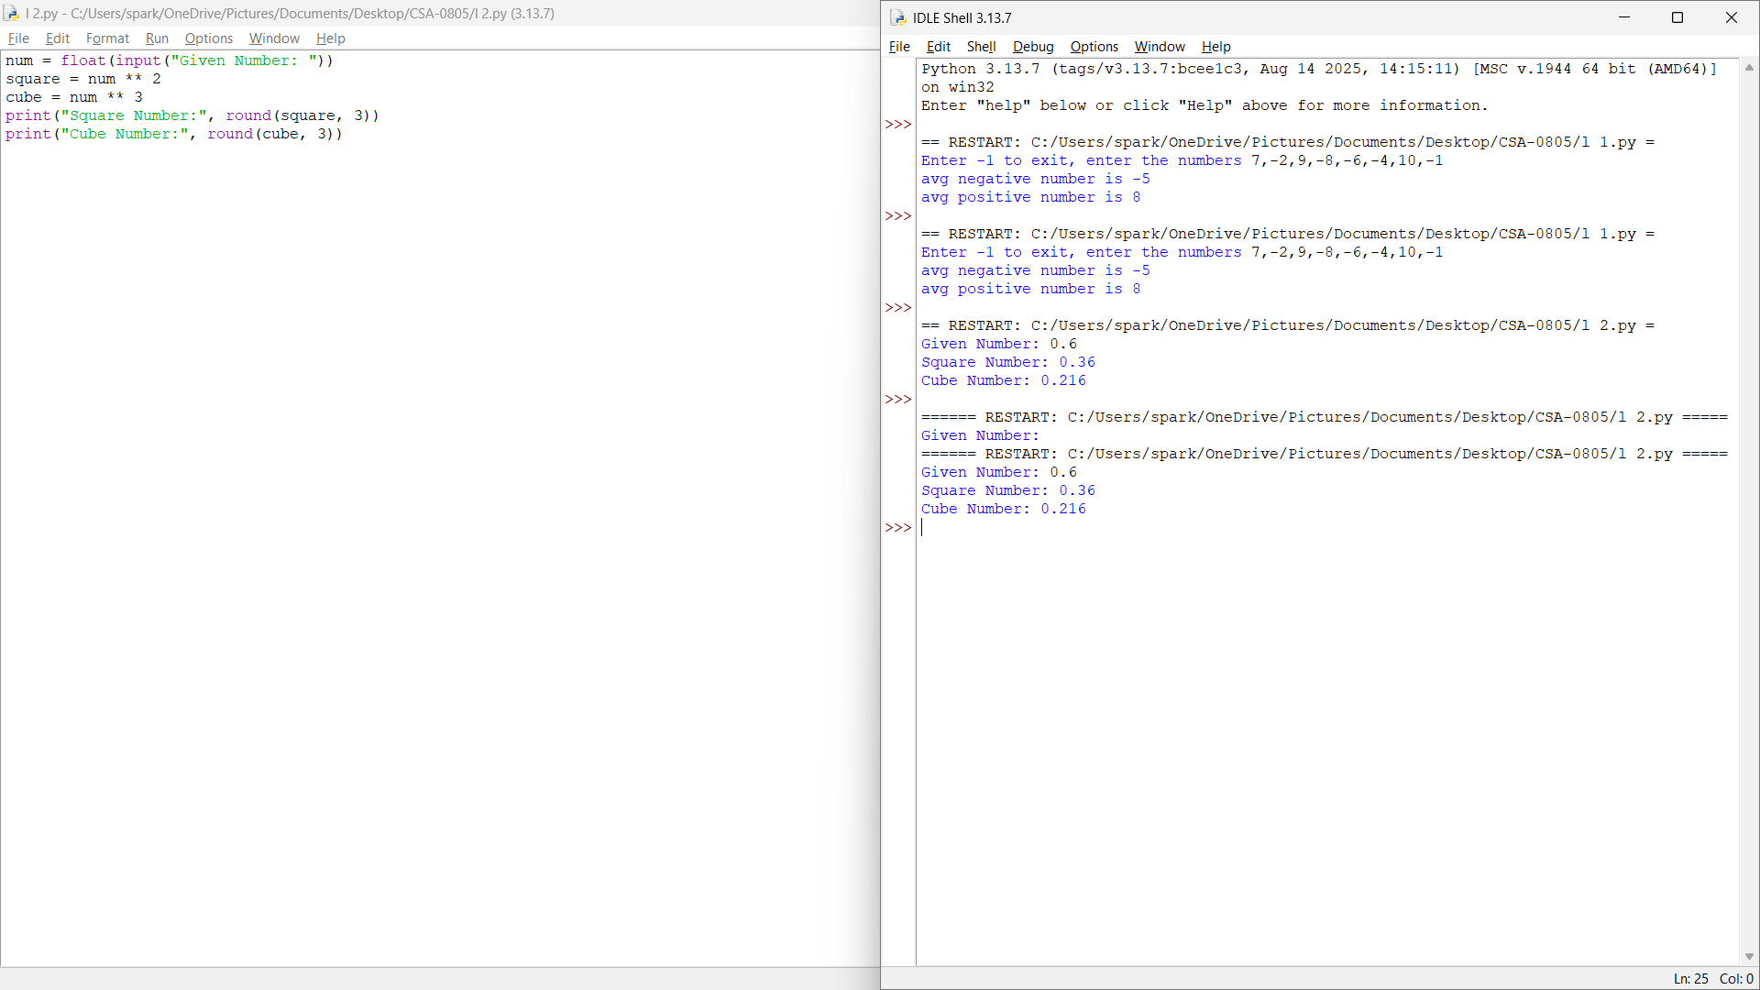

3.Write a python program to print the following pattern.
Sample Input:
Enter the Character to be printed:+
Number of rows.: 5
Output:
+
+ +
+ + +
+ + + +
+ + + + +
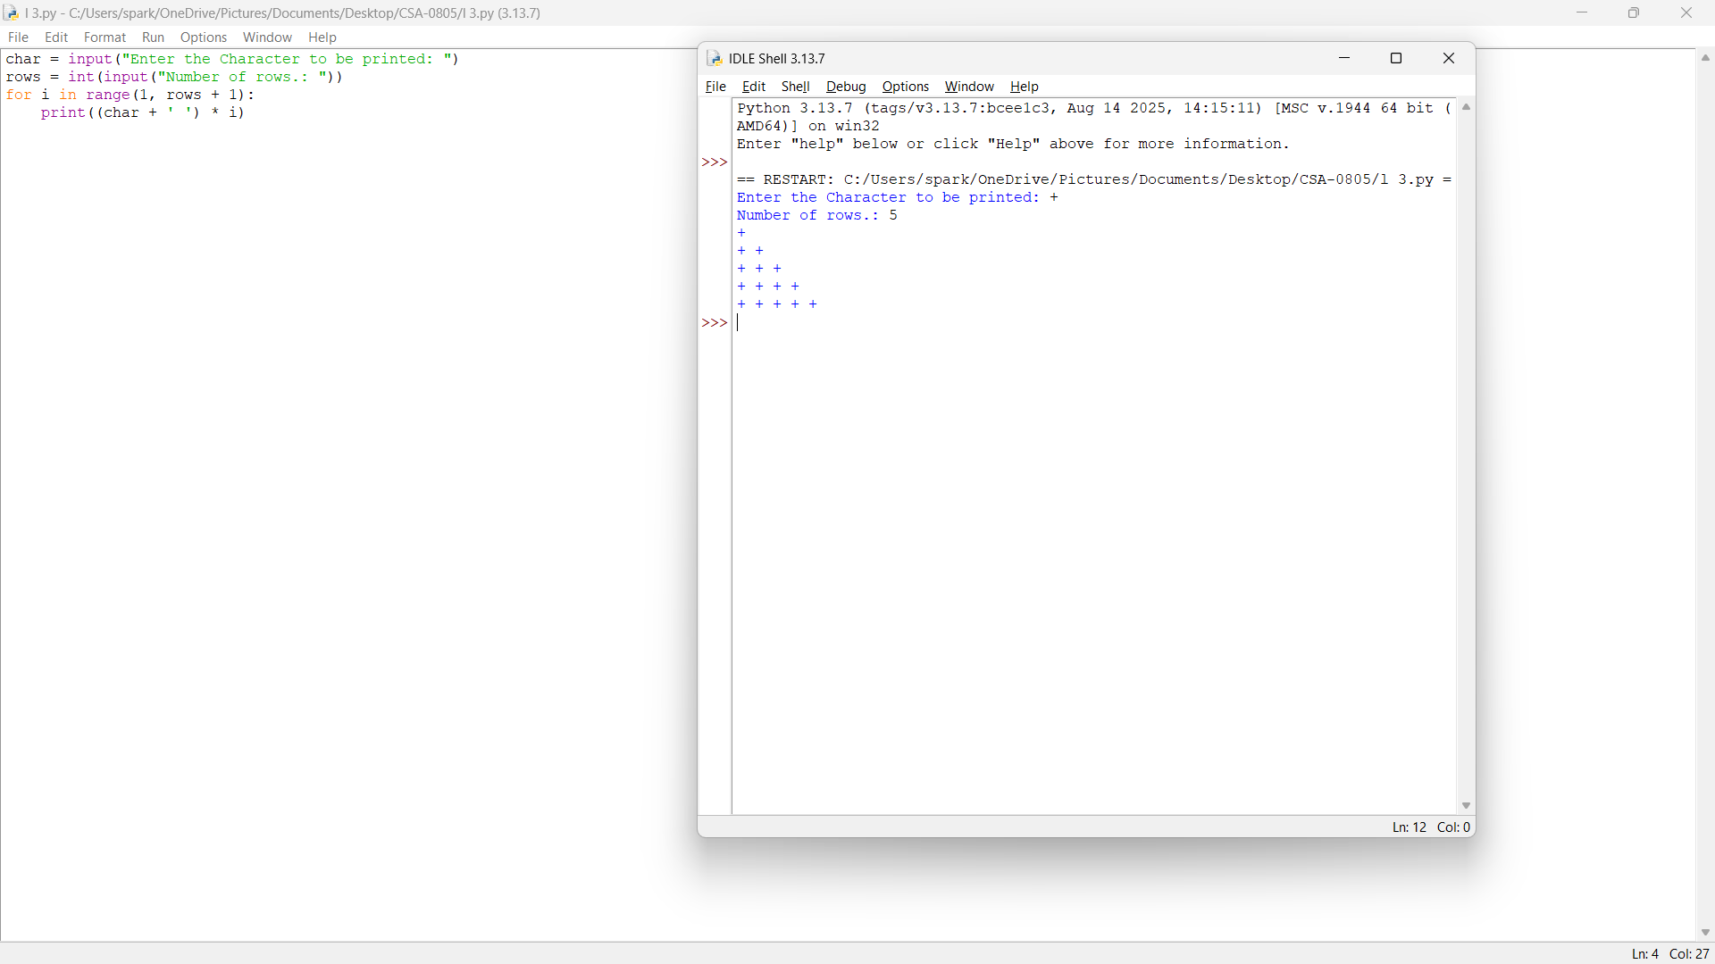

4.Python Program to Display the Multiplication Table
Sample Input:
A=7
B=5
Output:
7 x 1 = 7
7 x 2 = 14
7 x 3 = 21
7 x 4 = 28
- x 5 = 35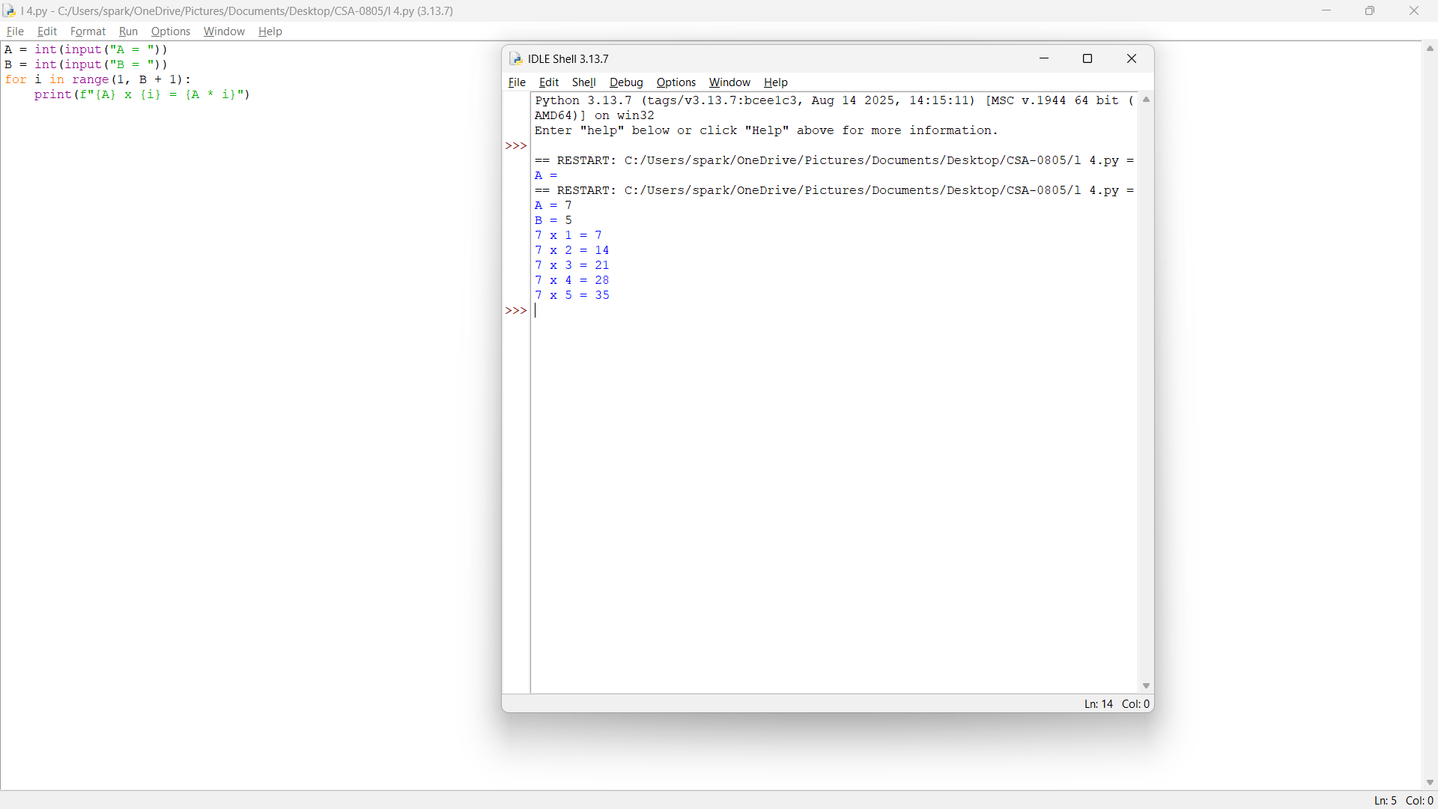

5.Write a program to find whether it is leap year or not?
Sample Input: 2000
Output: Leap Year

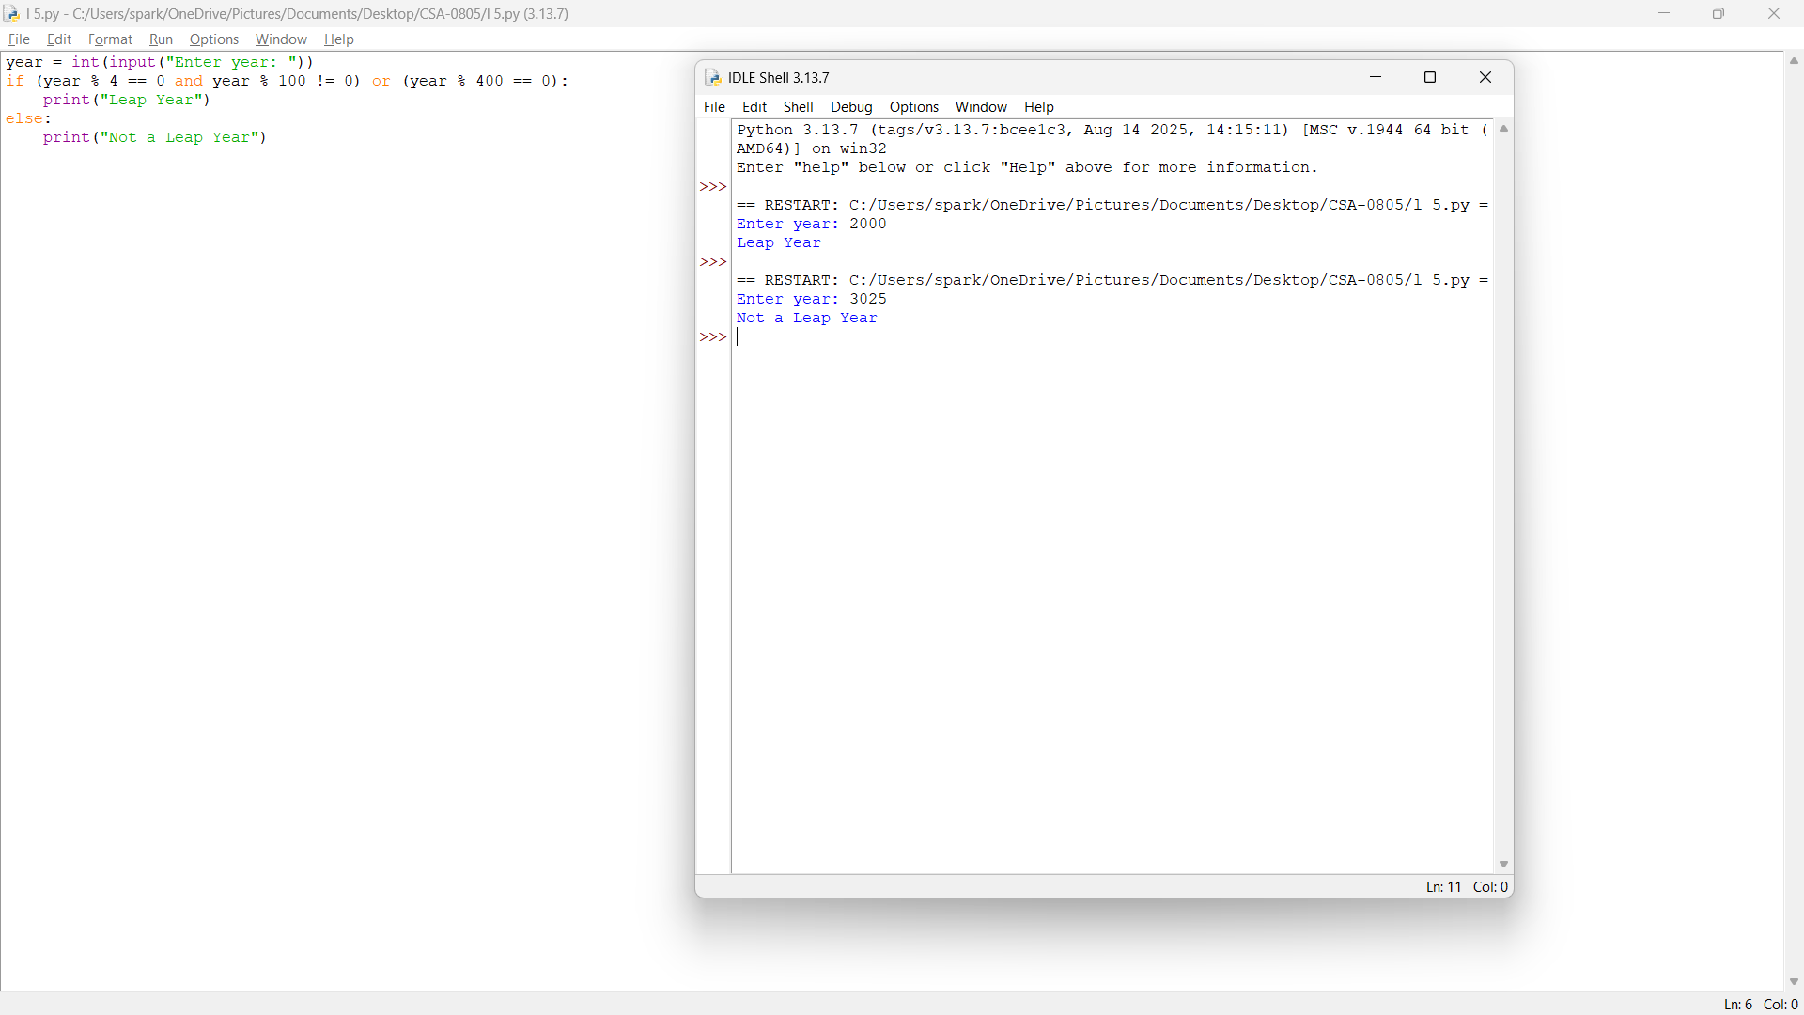

6.Write a program to find out the duplicate array
Sample Input: array={1,2,3,4,1}
- Output: duplicate array={1,2,3,4}
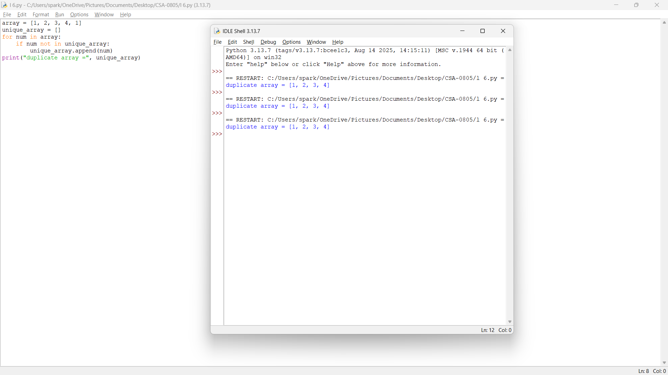

7. Check whether the number is positive or negative
Sample Input:23
Output: positive
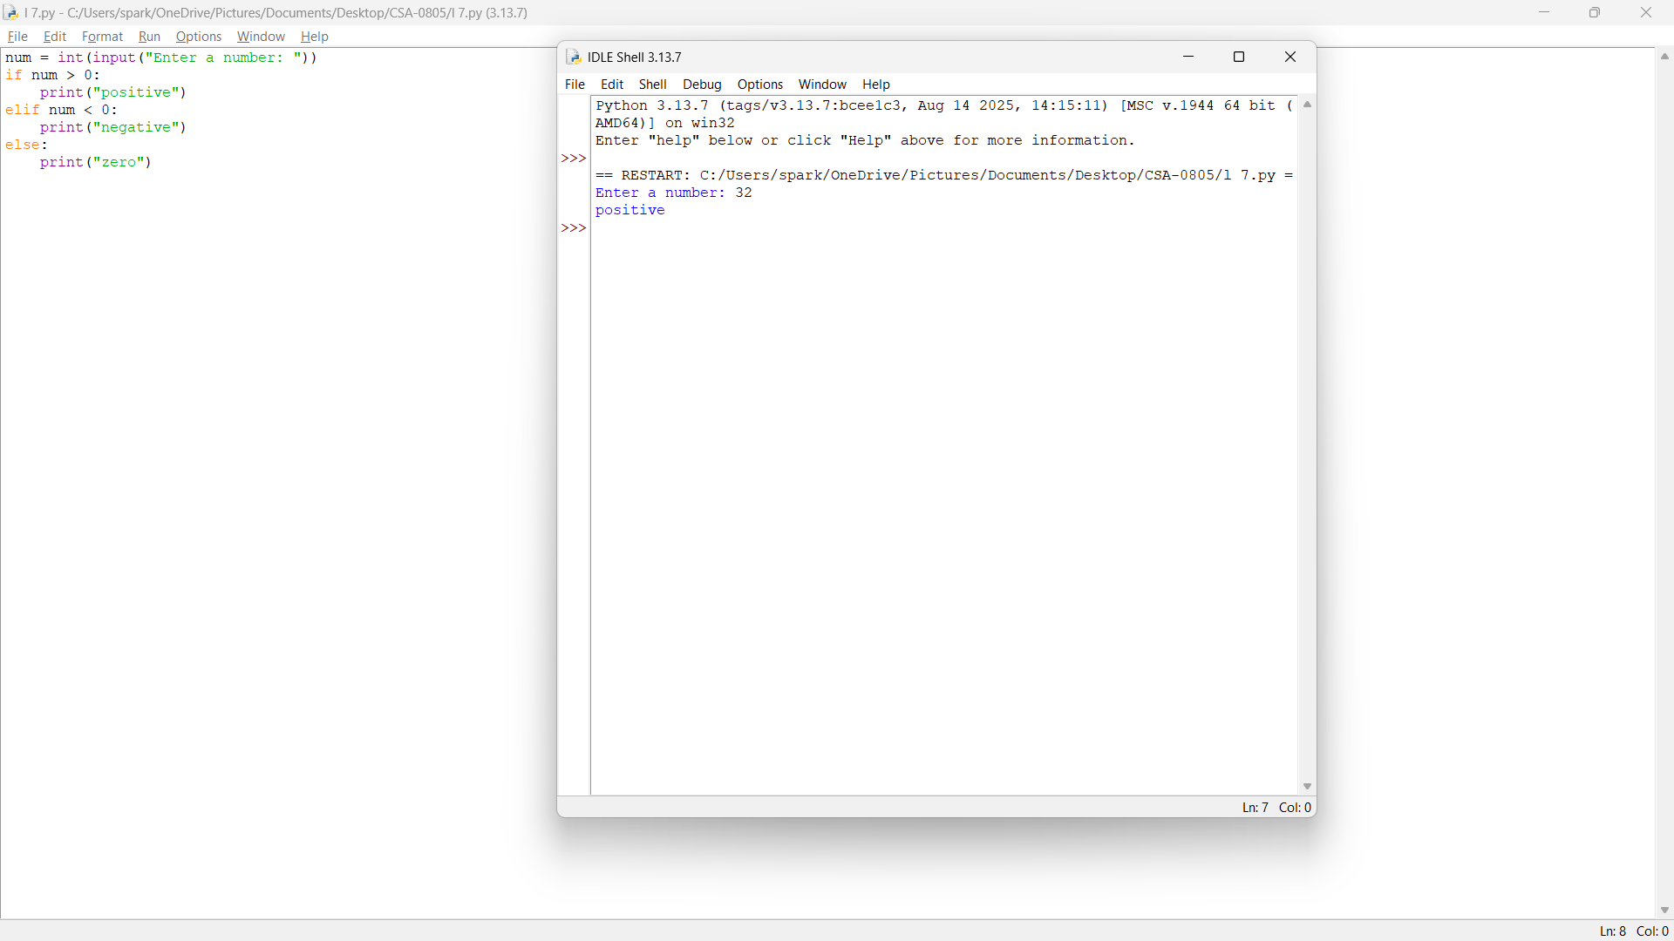

8.Write a python program to find the average of mean median mode
Sample Input: [12,45,83,52]/4
- Output: utput:48
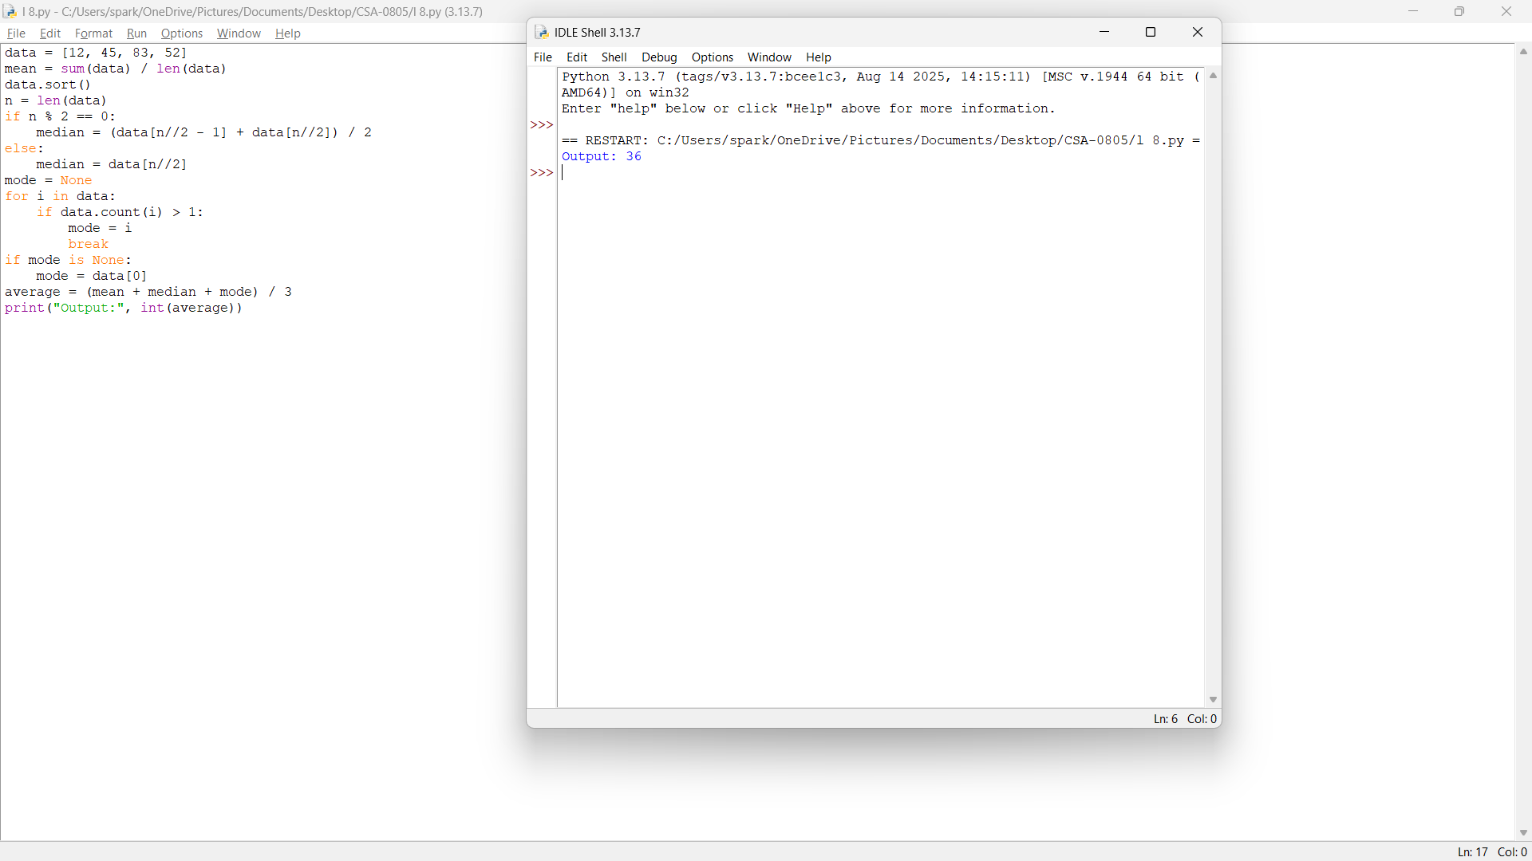

9.Write a python program to store the arrays in non-increasing order
Sample Input:[1,8,3,4,0]
- Output:[8,4,3,1,0]
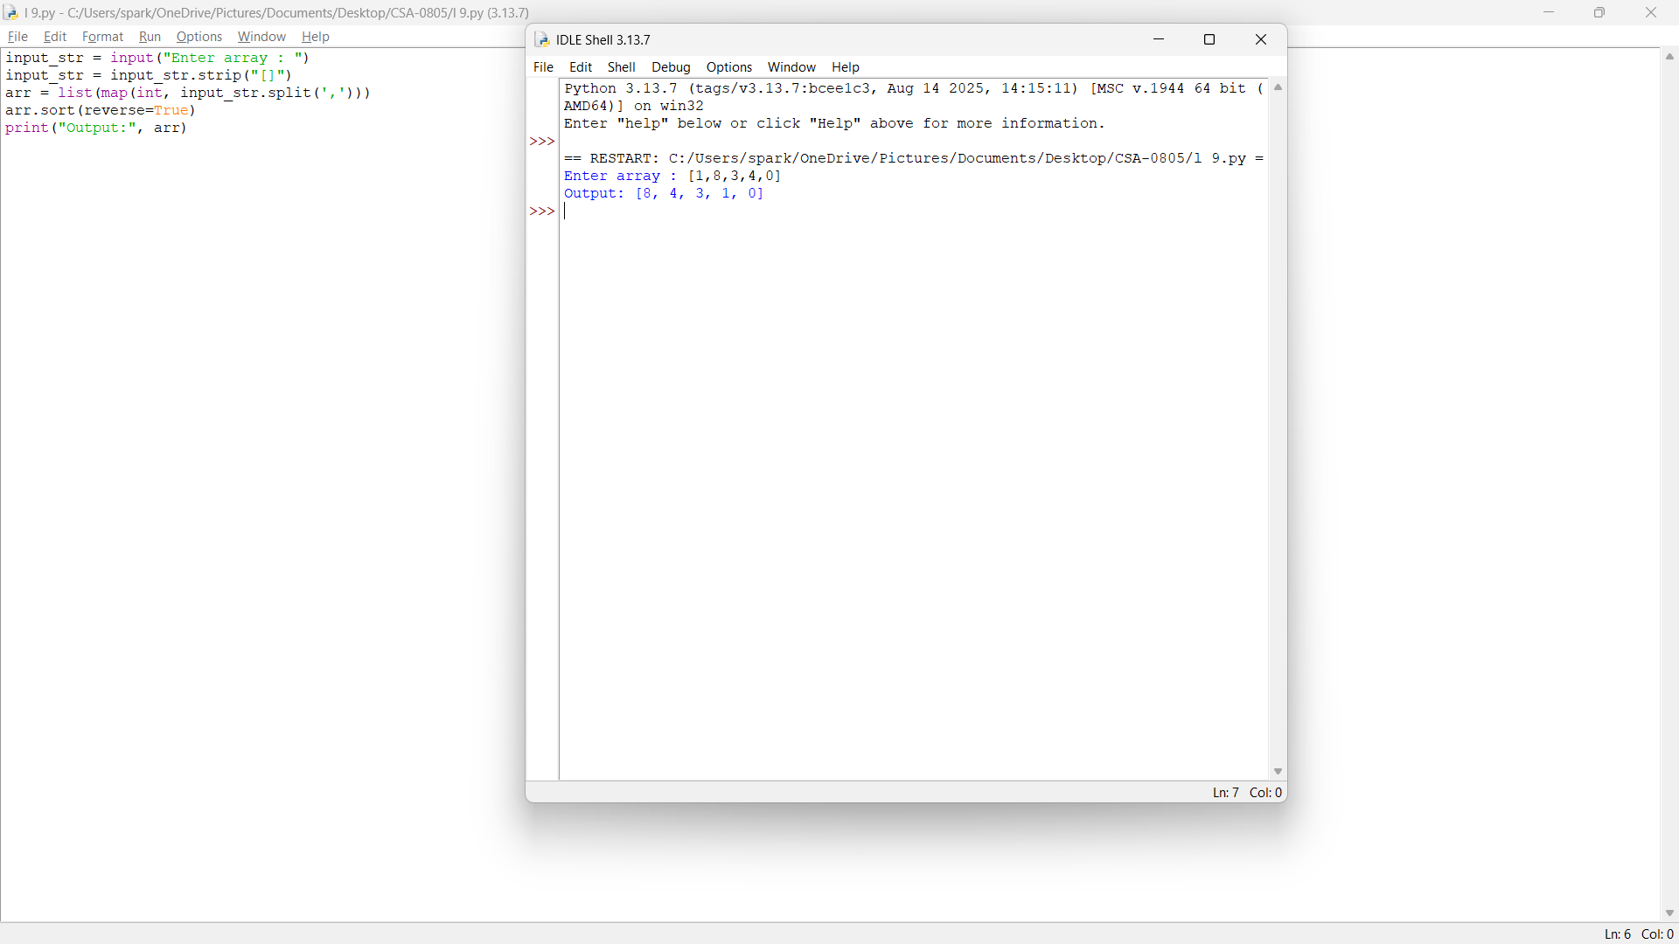

10.Write a Python Program to Intersecting an elements
Sample Input:
(2,3,4,5)
(3,4,8,6)
Output:
- (3,4)
